Project Setup Instructions

1. Clone the Repository

2. Create and Activate Python Environment

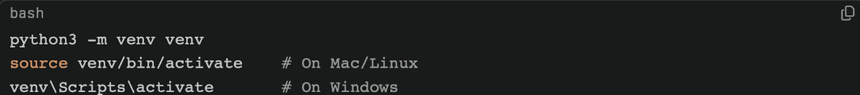

3. Install Dependencies

4. Add Your Groq API Key
Create a file called `.env`, and add:

5. Prepare Data files

Place input files (e.g., `financials.xlsx`) in the `data/` folder.financial-multi-agent/

6. Check the System with `simple_test.py` ← RUN THIS FIRST!

This script will quickly test all agents (analysis, risk, strategy).

6. Run The Main Analysis ( Might give an error because of Groq’s free tier API)

7. Generate PDF Report

The analyzed output will save to `output/financial_report.pdf`.

NOTE: This project uses Groq’s free tier API, which enforces strict token limits. Run tests with small files and concise prompts.

